**Cmyse Project**

**INF 280 Database Systems**

Prof. Tuparov

02.05.2022

**Airport Database**

Elena Ivanova - Developer

**Table of Content:**

1. Introduction
2. Entities and Attributes
3. Relational Mapping
4. Final ER Diagram
5. Illustration of tables
6. Queries
7. **Introduction**

The idea for this database came from my love for traveling and flying with a plane, in general. I all had a really hard time being able to go out and enjoy the world. While researching which entities to include and make a real database of an airport, I learned a lot of things that people do not. It is very interesting and interactive to learn how airports work and how important it is to keep their information safe. There are a lot of things that should be taken into consideration like how many people are getting a ticket when the plane is leaving, and what the bags’ weight is. There are also certain people, who are working at the airport and their personal information should also be taken into consideration. While making this database I realized how hard it is to keep everything under control and be prepared for every little inconvenience that may occur while implementing the database.

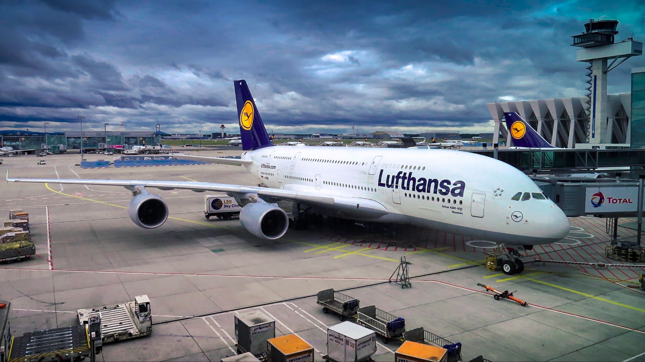

1. **Entities and Attributes**

***List of entities:***

*customer route department fare*

*ticket airline company employee*

*flight airport dependent*

* airline company

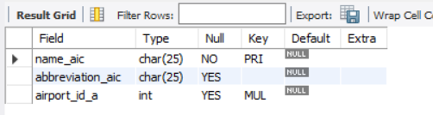

* airport

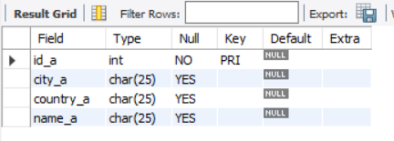

* customer

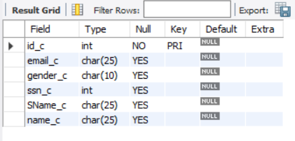

* department

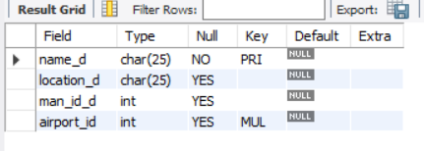

* dependent

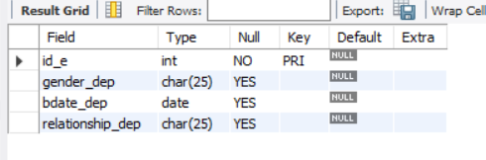

* employee

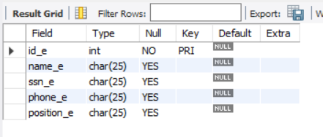

* fare

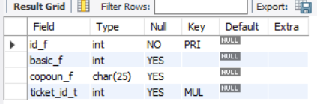

* flight

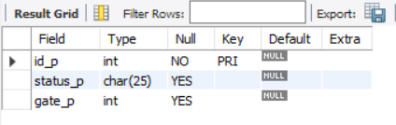

* route

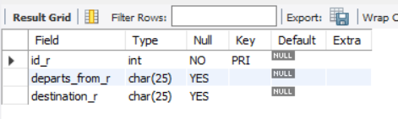

* ticket

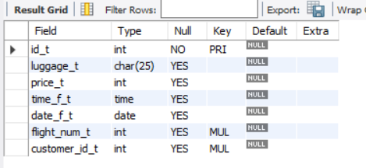

1. **Relational Mapping**

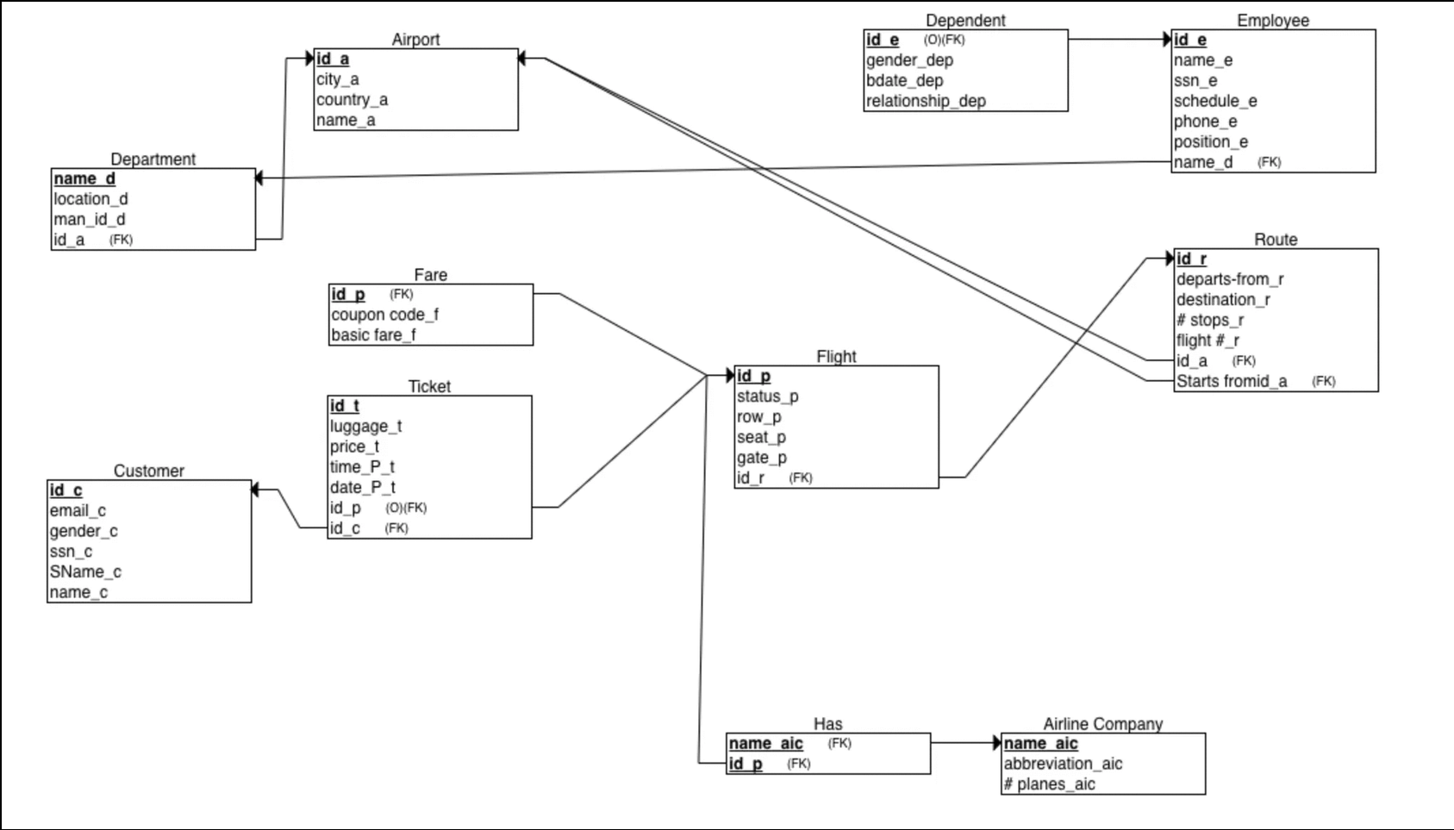

The mapping is normalized to 3rd normalization form.

1. **ER diagram**

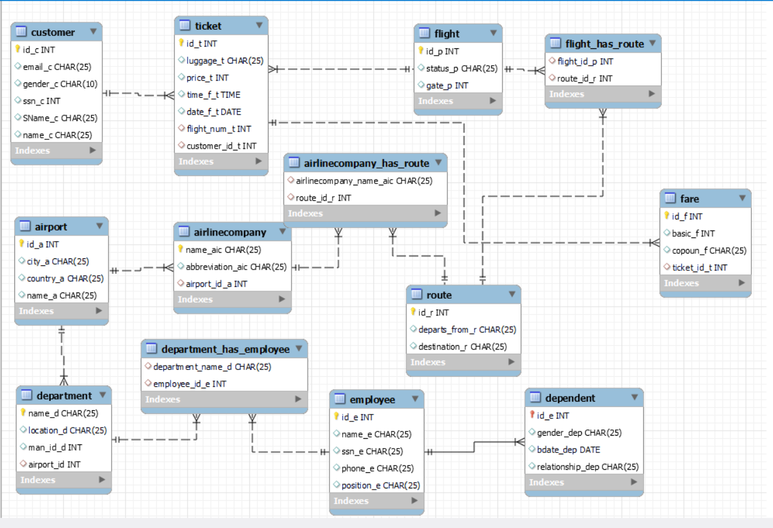

1. **Illustration of tables**

* all tables

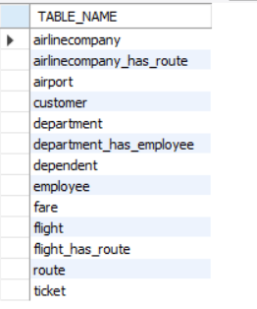

* ticket

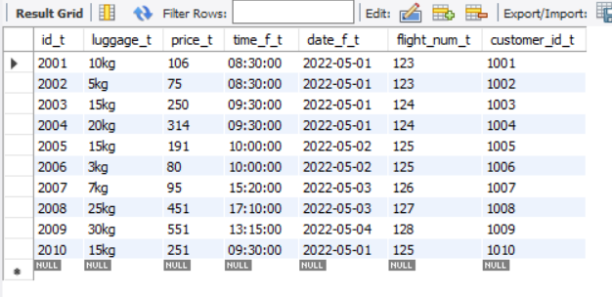

* route

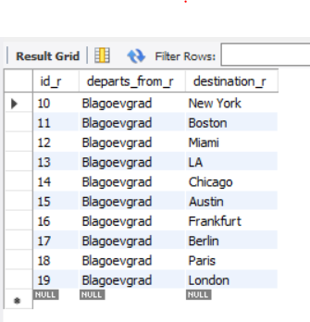

* flight

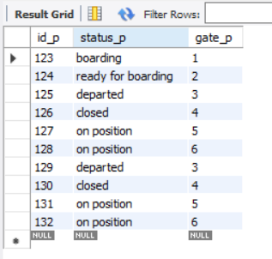

* flight has route

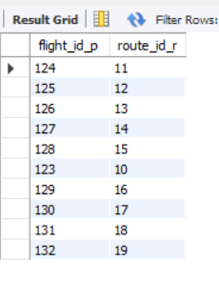

* fare

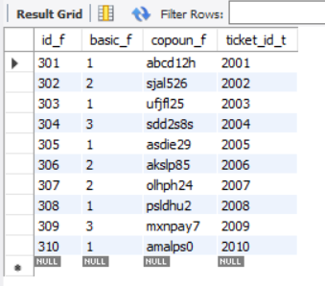

* employee

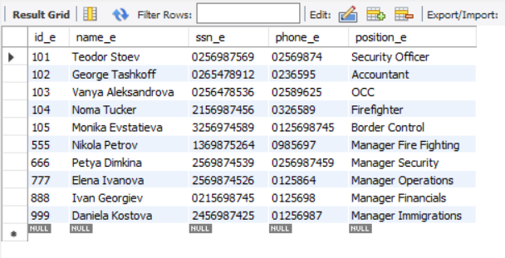

* dependent

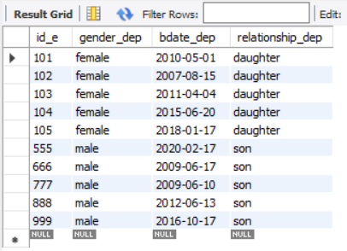

* department

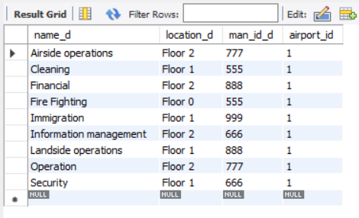

* department has employee

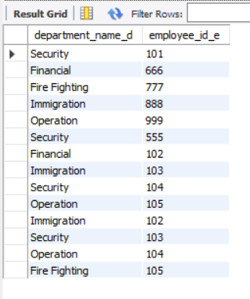

* customer

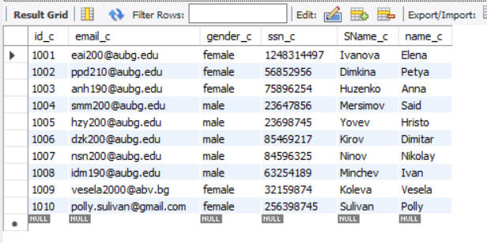

* airport

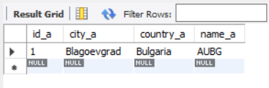

* airline company

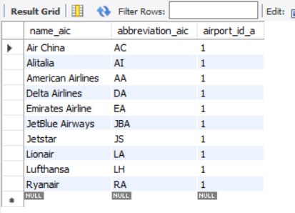

* airline company has a route

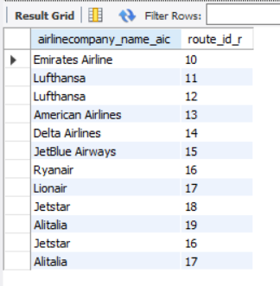

1. **Queries**

